Exhibitor’s Manual for China International Import Expo
Enterprise & Business Exhibition
Part III Booth Design and Setup
- Official Constructors
Responsible Area: | 7.1H/7.2H/8.2H | 3H/4.1H | 5.1H/5.2H/6.1H | 1H/2H
Chinese Name: | 北京华毅东方展览有限公司 | 上海鸿达展览服务有限公司 | 广州交易会广告有限公司 | 北京笔克展览服务有限公司
English Name: | ORIENTAL Expo SERVICES(BEIJING) CO., LTD. | SHANGHAI HONG DA EXHIBITION SERVICE CO., LTD. | CANTON FAIR ADVERTISING CO., LTD. | BEIJING PICO EXHIBITION SERVICES CO., LTD.
Address: | Room606, 6th Floor, Ruichen International Center, No.13, South Agricultural Exhibition Center Road, Chaoyang District, Beijing | 12th Floor, Jincheng Building, No. 511, West Tianmu Road, Shanghai | 4th Floor, Exhibition Hall #3, NECC (Shanghai), No. 1988, Zhuguang Road, Qingpu District, Shanghai | No. 3, Shunxing Road, Shunyi District, Beijing
Contact 1: | Wang Jingyang | Li Yingjun | Qi Siying | Zhang Lanyun
Tel: | +86-21-67008951 | +86-21-67008953 | +86-21-67008955 | +86-21-67008957
Mobile: | 18510588867 | 13761632455 | 15221206825 | 13011090211
Email: | 01constructor@ciie.org | 02constructor@ciie.org | 03constructor@ciie.org | 04constructor@ciie.org
Contact 2: | Wang Miaomiao | Ge Moqian | Chen Yujian | Niu Heming
Tel: | +86-21-67008952 | +86-21-67008954 | +86-21-67008956 | +86-21-67008958
Mobile: | 18601928198 | 18221975792 | 13610041071 | 13910393664
Email: | 01constructor@ciie.org | 02constructor@ciie.org | 03constructor@ciie.org | 04constructor@ciie.org
Contact 3: | Yang Shenglian | Wang Birong | Su Dan | Yu Haifeng
Tel: | +86-21-67008952 | +86-21-67008954 | +86-21-67008956 | +86-21-67008958
Mobile: | 18610395187 | 18817488170 | 13922249245 | 13522761318
Email: | 01constructor@ciie.org | 02constructor@ciie.org | 03constructor@ciie.org | 04constructor@ciie.org

- Renting Supporting Facilities
2.1 Renting Water, Electricity and Gas Facilities
- Any exhibitor in need of water supply, electricity and gas facilities at the booth shall submit a lease application to the official constructor prior to September 25th, 2018. Please refer to Form 6: Application for Lease of Supporting Facilities for details.

- Any exhibitor in need of 24h power supply at the booth shall submit an application to the official constructor prior to September 25th, 2018. Please refer to Form 7: Application for 24H Power Supply at the Booth for details.

- Any exhibitor in need of water, electricity and gas supply in advance at the booth shall submit an application to the official constructor prior to September 25th, 2018. Please refer to Form 8: Application for Advance Water, Electricity and Gas Supply for details.

- If it is not permitted, or it is unsuitable to install leakage protectors for special reasons (for example, the distribution lines for special power use such as mechanical power consumption and silicon-controlled rectifier), the exhibitor shall submit an application to the official constructor prior to September 25th, 2018. Please refer to Form 9: Application for Removal of Distribution Box Leakage Protector for details.

- If any exhibitor has any special requirements for compressed air or requires the supply of compressed air of over 1.6 m³/min, it is recommended that the exhibitor brings his/her own air compressors and submits an application to the official constructor prior to September 25th, 2018. Please refer to Form 3: Application for Special Items Entry for details.

2.2 Renting Network and Phone Facilities
Any exhibitor in need of renting supporting network and phone facilities shall submit an application to the official constructor prior to September 25th, 2018. Please refer to Form 6: Application for Lease of Supporting Facilities for details.

2.3 Renting Exhibition Equipment
Any exhibitor in need of renting exhibition equipment shall submit an application to the official constructor prior to September 25th, 2018. Your requirements cannot be fulfilled if the application is made on-site during the Expo. Please refer to Form 10: Application for Lease of Exhibition Equipment for details.

2.4 Renting Flowers and Green Plants
Any exhibitor in need of renting flowers and green plants shall submit an application to the official constructor prior to September 25th, 2018 or apply at the Expo Service Center at the site. Please refer to Form 11: Application for Lease of Flowers and Green Plants for details.

- Standard Booths
3.1 Notice to Exhibitors Using Standard Booths
- Exhibitors using standard booths are required to fill out a Booth Fascia Board Information Form. Please send the form to the designated official constructor prior to September 25th, 2018. Please do not cover up or modify the fascia board without permission. Please refer to Form 12: Standard Booth Fascia Board Information Form for details.

- For other details, please refer to Appendix 5: Notice to Exhibitors with Standard Booths.

3.2 Booth Size
Standard size: 2,970 MM×2,970 MM, total height 4,000 MM, partition wall height 2,500 MM, distance from fascia board bottom to the floor 2,450 MM, fascia board height 450 MM (including frame), fascia board length 1,800 MM (including frame).

3.3 Basic Equipment
One square table, four folding chairs, one floor cabinet (1000*500*500H), one glass showcase (1000*500*2000H), one reception counter (1000*500*750H), three laminate panels (for garment booths, the three laminate panels will be replaced by 2,440H*950 slot plates and 16 hooks), four LED spotlights, one 500W socket (Chinese standard) and one trash can.

  - Booth Layout
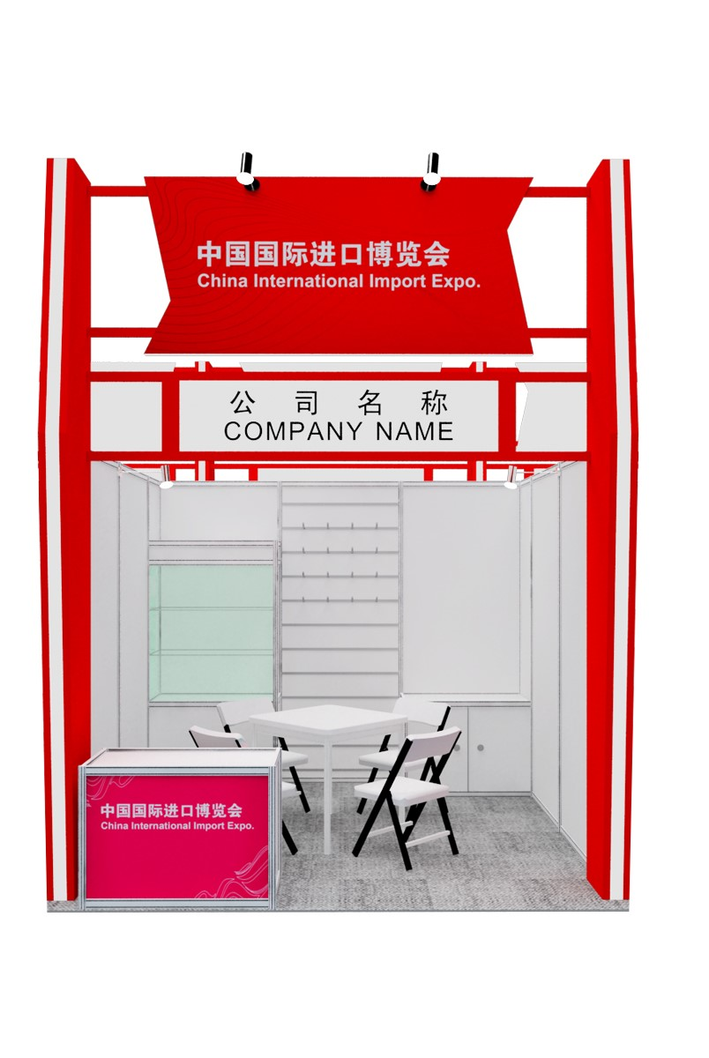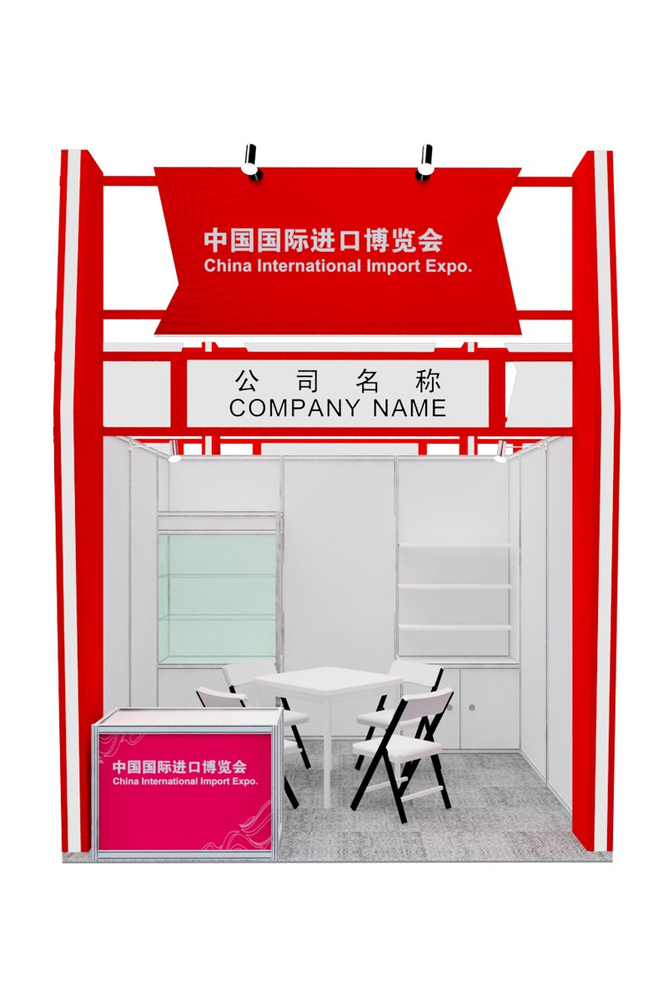
- Special Booth Design and Setup
4.1 Safety Responsibility Letter
In order to further strengthen work safety at the Expo, the Organizers have drawn up the Safety Responsibility Letter for Special Booth, which shall be signed by all special booth constructors and submitted to the official constructor prior to September 15th, 2018. For more information, please refer to Form 13: Special Booth Safety Responsibility Letter.

4.2 Recommended Special Booth Constructors
In order to strengthen work safety control of special booths and ensure the Organizers and venue’s relevant rules and requirements on work safety are strictly observed in the booth setup, dismantling and maintenance during the Expo, the Organizers specially recommend experienced special booth constructors with good credential and strict management system for exhibitors’ option. For more details, please refer to Appendix 6: List of Recommended Special Booth Constructors.
Any exhibitor who wishes to take his/her own special booth constructor in the venue shall submit an application to the Organizers prior to July 31st, 2018. Please refer to Form 14: Application for BYO Special Booth Constructor for details. If the application is accepted, the exhibitor or its own special booth constructor shall sign a Special Booth Safety Responsibility Letter and submit it to the official constructor of the exhibition area prior to September 15th, 2018. For more information, please refer to Form 13: Special Booth Safety Responsibility Letter. Furthermore, the exhibitor or his/her own special booth constructor shall pay a site deposit to the Organizers within 15 days after receiving the notice that the application is accepted (The deposit shall be returned without interest attached if there are no damages to the facilities at the site after the Expo ends). The site deposit shall be paid at the rate of RMB500/m² (net area) but not more than RMB300,000 for each booth.

4.3 Notice to Exhibitors with Special Booths
Exhibitors shall entrust the recommended or the approved special booth constructors to take charge of booth design and setup. The Expo and drawing inspectors will not accept any drawings submitted by special booth constructors that failed the qualification review. Special booth constructors shall abide by the rules of the Notice to Exhibitors with Special Booths during booth design and setup. Please refer to Appendix 7: Notice to Exhibitors with Special Booths for details.
Any agreement or arrangement between an exhibitor and a special booth constructor is a contract between the two sides. In case of any accident or dispute, the two sides shall resort to legal means to resolve them, and the Expo will assume no liability.

4.4 Drawing Inspection
To ensure the safety and stability of special booth setup and avoid any possible risk and hidden danger, the maximum height permitted for the booths at the Expo is 6 meters for single-story booths and 8.5 meters for two-story booths. Exhibitors with special booths shall submit relevant documents to the official constructor of the venue for examination and review. For two-story special booths and single-story special booths that are taller than 4.5 m (inclusive), the exhibitors shall also submit materials to the drawing inspector for height-based structural inspection. Exhibitors subject to height-based structural inspection shall pay for the drawing inspection.
Official constructors will be in charge of inspecting the structure of single-story special booths below 4.5 m(exclusive), and file the details of the materials of single-story special booths above 4.5 m (inclusive) and two-story special booths for the record.
Drawing inspectors will be in charge of inspecting the structure of single-story special booths above 4.5 m (inclusive) and two-story special booths, and shall collect the inspection fee.

    - Official Drawing Inspectors
Responsible Area: | 5.1H/6.1H/5.2H/7.1H/7.2H/8.2H | 1H/2H/3H/4.1H
Chinese Name: | 上海海展广告工程有限公司 | 上海亚海恒欣会展有限公司
English Name: | SHANGHAI HIGH-FAIR ADVERTISING & ENGINEERING CO., LTD. | SHANGHAI ASEA HENGXIN CONVENTION & EXHIBITION CO., LTD.
Address: | 4th Floor, Exhibition Hall #3, NECC (Shanghai), No. 1988, Zhuguang Road, Qingpu District, Shanghai | West Zone, 5th Floor, South Building D, No. 787, Xiehe Road, Changning District, Shanghai
Contact 1: | Li Jingfeng | Chu Shunshun
Tel: | +86-21-67008967 | +86-21-67008969
Mobile: | 13824411285 | 18616576611
Contact 2: | Yu Le | Jia Fengqiao
Tel: | +86-21-67008968 | +86-21-67008970
Mobile: | 13922251667 | 15902199806
Contact 3: | Han Xiaolei
Tel: | +86-21-67008968
Mobile: | 13710015934
Email: | 01inspector@ciie.org | 02inspector@ciie.org

4.4.2 Notice on Drawing Inspection
- Exhibitors with special booths shall submit a special booth setup application and relevant materials to the official constructor of the venue prior to September 15th, 2018. For two-story special booths and single-story special booths taller than 4.5 m (inclusive), the exhibitors shall submit materials to both the official constructor and the official drawing inspector for inspection. Please refer to Form 15: Application for Special Booth Setup for details.

- Calculation of booth drawing inspection fee: drawing inspection fee/m² × booth area. Unit price of drawing inspection: drawing inspection fee for indoor two-story booths is RMB25/m²; drawing inspection fee for indoor single-story booths is RMB20/m²; drawing inspection fee for outdoor two-story booths is RMB30/m²; drawing inspection fee for outdoor single-story booths is RMB25/m². Charged area for drawing inspection: single-story booth charged area = booth area; two-story booth charged area = the area of upper story + the load-bearing area of the base floor caused by that of the upper structure.

4.5 Standards of Green Booths
To advocate the idea of green and environmental protection, the Expo has especially established the Criteria for Green China International Import Expo, which includes green booth, green operation, green logistics and green catering. Specifically, relevant standards are formulated for three stages, i.e. green design, green material selection, and green safety construction. Exhibitors and constructors are advised to positively respond and work as per the green standards. Please refer to Appendix 8: Criteria for Green China International Import Expo for details.
- Overtime
During move-in and move-out, exhibitors may work until 22:00 (10:00 p.m.) each day. In case of any need to work after 22:00, the exhibitor shall submit an application to the Expo Service Center before 18:00 (6:00 p.m.) of the same day. The exhibitor may work overtime after obtaining the Organizers’ approval.

- Site Acceptance
Booth constructors shall remove and dismantle all booth materials within the timeframe specified in the Expo Agenda in this Manual and shall comply with all concerned provisions in this Manual. For more details, please refer to the Rules and Regulations in this Manual.

BYO = Bring Your Own

