Exhibitor’s Manual for China International Import Expo
Enterprise & Business Exhibition
Opening Remarks
Dear Exhibitors,
In May 2017, Chinese President Xi Jinping announced that China would host China International Import Expo (CIIE) from 2018 onwards and that the first session would be held in Shanghai from November 5 to 10, 2018 at the Belt and Road Forum for International Cooperation. The CIIE will mark a significant move for the Chinese government to push forward a new round of high-level opening-up, and an important measure to actively open the Chinese market to the world. It will serve as an open cooperation platform for countries and regions across the world to showcase their development achievements and launch international trade, and also an international public product for promoting trade liberalization and economic globalization.
The first CIIE will set up a business show for enterprises, including two divisions of goods trade and service trade. Goods trade division will comprise exhibition areas of intelligent & high-end equipment, consumer electronics & home appliances, apparel & accessories and daily consumer goods, automobile, food & agricultural products, medical equipment & healthcare products, etc. Service trade division will comprise exhibition areas of emerging technology, service outsourcing, creative design, culture & education, tourism service, logistics service, comprehensive service, etc. During the Expo, Hongqiao International Trade Forum as well as a series of substantial trade promotion activities will be held. Enterprises from more than 100 countries and regions will participate in the Expo, and 150,000 professional buyers are expected to attend the exhibition.
In the next five years, China is expected to import over 10 trillion USD goods and services, which means a historic opportunity for enterprises across the globe to expand their business in the market of China.
On behalf of the CIIE organizing committee, we hereby sincerely thank you for your participation in the CIIE to showcase your most competitive products and services, promote global trade growth, and achieve greater mutual benefit and win-win cooperation. We look forward to your coming to Shanghai, China!

China International Import Expo (CIIE)

Notes
Dear Exhibitors,
In order to help you understand about the venue facilities and various requirements of the Expo, and to help you prepare well, we are providing this Exhibitor’s Manual so that you will pass through the participation formalities more quickly and efficiently.
- Forms to Fill In
Forms to be filled in are listed in Part Ⅶ “Forms” of the Exhibitor’s Manual. Please read them carefully and submit the filled-out forms by the deadlines indicated separately in the Tables of Content and in the forms. It is suggested to make a copy of the forms as backups before filling them out and sending them back.
- Safety Notes
Please read carefully the rules and regulations in this Exhibitor’s Manual on safe working conditions, fire safety and civilized participation in the Expo, and urge your service providers to strictly follow these rules and regulations as well.
- Disclaimer
The Organizers of CIIE will make every effort to provide best quality services in every aspect, to meet the exhibitors’ requirements; the Organizers, however, shall not bear any liability arising from the following situations:
- Any delay or failure to provide all or part of the services due to delayed return of the forms by the exhibitor after the deadline.
- Any surcharge or failure to provide all or part of the services resulting from delayed submission of application by the exhibitor after the deadline.
- Any delay, compensation, damage due to failure to comply with the Expo rules and regulations and relevant laws by the exhibitor.
- Any delay, damage, disputes due to the engagement with any non-designated service provider by the exhibitor.
- Any inaccuracy in the publication materials provided by the exhibitor or constructor, or delayed submission.

Part One: General Information of the Expo

- Basic Information
  - Name of the Expo
China International Import Expo (CIIE)
1.2 Time
November 5-10, 2018
1.3 Venue
National Exhibition and Convention Center (Shanghai) (NECC)
Address: No. 333, Songze Avenue, Qingpu District, Shanghai
  - Hosts
Ministry of Commerce of the People’s Republic of China
Shanghai Municipal People’s Government
  - Supporters
The World Trade Organization (WTO)
United Nations Industrial Development Organization (UNIDO)
United Nations Conference on Trade and Development (UNCTD)
  - Organizers
China International Import Expo Bureau
National Exhibition and Convention Center (Shanghai)

  - Expo Layout
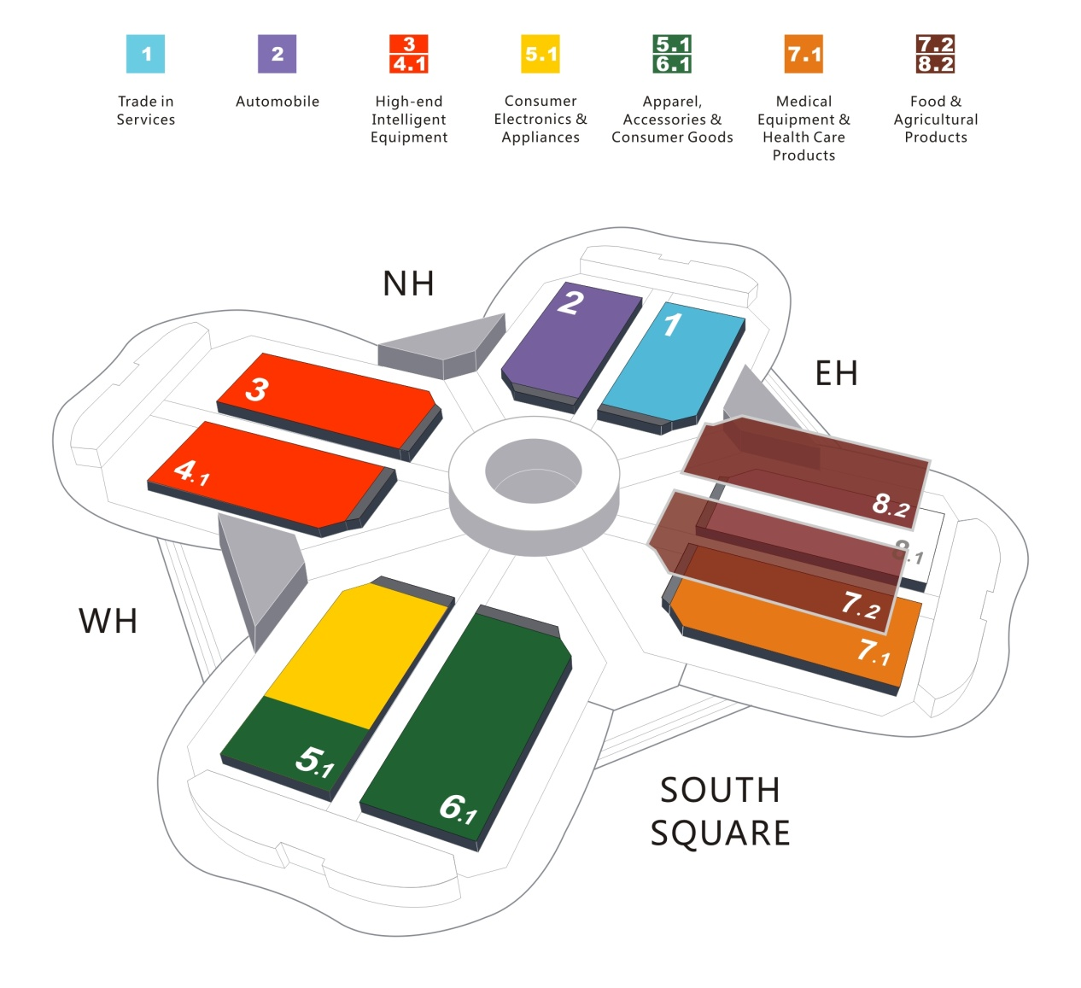
  - Trade Forum
Name: Hongqiao International Trade Forum
Date: November 5, 2018
Venue: NECC (Shanghai)
Hosts: Ministry of Commerce of the People’s Republic of China;
Shanghai Municipal People’s Government
Supporters: WTO, UNIDO, UNCTD
Organizers: China International Import Expo Bureau;
National Exhibition and Convention Center (Shanghai)
  - Official Website
www.ciie.org.
2. Expo Contact List
2.1 Contact Information of the Organizers
China International Import Expo Bureau
National Exhibition and Convention Center (Shanghai)
Address: No.333, Songze Avenue, Shanghai, China
Exhibitor Information: +86-21-67008870/ 67008988
Service Hotline: +86-21-968888
Fax: +86-21-67008811
E-mail: info@ciie.org
2.2 Official Service Suppliers
2.2.1 Official Constructors
Responsible Area: | 7.1H/7.2H/8.2H | 3H/4.1H | 5.1H/5.2H/6.1H | 1H/2H
Chinese Name: | 北京华毅东方展览有限公司 | 上海鸿达展览服务有限公司 | 广州交易会广告有限公司 | 北京笔克展览服务有限公司
English Name: | ORIENTAL Expo SERVICES(BEIJING) LIMITED | SHANGHAI HONG DA EXHIBITION SERVICE CO., LTD. | CANTON FAIR ADVERTISING CO., LTD. | BEIJING PICO EXHIBITION SERVICES CO., LTD.
Address: | Room 606, 6th Floor, Ruichen International Center, No.13, South Agricultural Exhibition Center Road, Chaoyang District, Beijing | 12th Floor, Jincheng Building, No.511, West Tianmu Road, Shanghai | 4th Floor, Exhibition Hall #3, NECC(Shanghai), No. 1988, Zhuguang Road, Qingpu District, Shanghai | No.3, Shunxing Road, Shunyi District, Beijing
Contacts 1: | Wang Jingyang | Li Yingjun | Qi Siying | Zhang Lanyun
Tel.： | +86-21-67008951 | +86-21-67008953 | +86-21-67008955 | +86-21-67008957
Mobile： | 18510588867 | 13761632455 | 15221206825 | 13011090211
E-mail： | 01constructor@ciie.org | 02constructor@ciie.org | 03constructor@ciie.org | 04constructor@ciie.org
Contacts 2: | Wang Miaomiao | Ge Moqian | Chen Yujian | Niu Heming
Tel.： | +86-21-67008952 | +86-21-67008954 | +86-21-67008956 | +86-21-67008958
Mobile： | 18601928198 | 18221975792 | 13610041071 | 13910393664
E-mail： | 01constructor@ciie.org | 02constructor@ciie.org | 03constructor@ciie.org | 04constructor@ciie.org
Contacts 3: | Yang Shenglian | Wang Birong | Su Dan | Yu Haifeng
Tel.： | +86-21-67008952 | +86-21-67008954 | +86-21-67008956 | +86-21-67008958
Mobile： | 18610395187 | 18817488170 | 13922249245 | 13522761318
E-mail： | 01constructor@ciie.org | 02constructor@ciie.org | 03constructor@ciie.org | 04constructor@ciie.org
2.2.2 Official Forwarders
Responsible Area: | 1H/2H | 5.1H/5.2H/6.1H | 3H/4.1H | 7.1H/7.2H/8.2H
Chinese Name: | 上海国际展览运输有限公司 | 中国外运华东有限公司 | 上海依佩克国际运输有限公司 | 上海欣越国际货物运输代理有限公司
English Name: | SHANGHAI ExpoTRANS LTD. | SINOTRANS EASTERN CO., LTD. ExpoSITION LOGISTICS BRANCH | SHANGHAI ITPC INT'L TRANSPORTATION CO., LTD. | GO-EXPRESS CO., LTD.
Address: | 10th Floor, No.555, Anyuan Road, Jingan District, Shanghai | 4th Floor, No.85, Ouyang Road, Hongkou District, Shanghai | Room 501, Minmetals Building, No.757, Guangfu Road, Jingan District, Shanghai | 17th Floor, Building C-D, No.277, Siping Road, Shanghai
Contacts 1: | Pan Feng | Li Jiong | Tang Shunjun | Xia Shijie
Tel.： | +86-21-67008959 | +86-21-67008961 | +86-21-67008963 | +86-21-67008965
Mobile： | 13817904002 | 18918781200 | 18616708519 | 13621692959
E-mail： | 01transporter@ciie.org | 02transporter@ciie.org | 03transporter@ciie.org | 04transporter@ciie.org
Contacts 2: | Cai Huihao | Du Chuankun | Gu Fangru | Xu Maodong
Tel.： | +86-21-67008960 | +86-21-67008962 | +86-21-67008964 | +86-21-67008966
Mobile： | 13636598550 | 13901863852 | 18602105358‬ | 13901960621
E-mail： | 01transporter@ciie.org | 02transporter@ciie.org | 03transporter@ciie.org | 04transporter@ciie.org
Contacts 3: | Cao Lijia | Li Yuemin | Meng Lingmin | Cai Junyi
Tel.： | +86-21-67008960 | +86-21-67008962 | +86-21-67008964 | +86-21-67008966
Mobile： | 13564072617 | 18930010715 | 13795307591‬ | 13611935480
E-mail： | 01transporter@ciie.org | 02transporter@ciie.org | 03transporter@ciie.org | 04transporter@ciie.org
Fax： | +86-21-60131881 | +86-21-65214083 | +86-21-62606624 | +86-21-65757716
    - Drawing Inspectors
Responsible Area: | 5.1H/6.1H/5.2H/7.1H/7.2H/8.2H | 1H/2H/3H/4.1H
Chinese Name: | 上海海展广告工程有限公司 | 上海亚海恒欣会展有限公司
English Name: | Shanghai High-Fair Advertising & Engineering Co., Ltd. | Shanghai ASEA Hengxin Convention & Exhibition Co., Ltd.
Address: | 4th Floor, Exhibition Hall #3, NECC(Shanghai), No. 1988, Zhuguang Road, Qingpu District, Shanghai | West Zone, 5th Floor, South Building D, No.787, Xiehe Road, Changning District, Shanghai
Contacts 1: | Li Jingfeng | Chu Shunshun
Tel.： | +86-21-67008967 | +86-21-67008969
Mobile： | 13824411285 | 18616576611
Contacts 2: | Han Xiaolei | Jia Fengqiao
Tel.： | +86-21-67008968 | +86-21-67008970
Mobile： | 13710015934 | 15902199806
Contacts 3: | Yu Le
Tel.： | +86-21-67008968
Mobile： | 13922251667
E-mail： | 01inspector@ciie.org | 02inspector@ciie.org
    - Advertising Agencies
Chinese Name： | 上海亚太广告有限公司
English Name： | Shanghai Asia-Pacific Advertising Co., Ltd.
Address： | Building 6, No.788, Xueye Road, Pudong New Area, Shanghai
Contacts 1： | Kang Zhenhua
Tel.： | +86-21-62107339-859
Mobile： | 13916906279
E-mail： | kangzhenhua@cpit-exhibition.com
Contacts 2： | Zhu Guangyi
Tel.： | +86-21-62107339-838
Mobile： | 13801727673
E-mail： | zhuguangyi@cpit-exhibition.com
Contacts 3： | Wang Chen
Tel.： | +86-21-62107339-845
Mobile： | 13917627074
E-mail： | wangchen@cpit-exhibition.com
Fax： | +86-21-62107350
  - Recommended Expo Service Suppliers
2.3.1 Recommended International Shipping Forwarder
Chinese Name: | 中国远洋海运集团有限公司
English Name: | China COSCO Shipping Corporation Limited
Address: | No.5299, Riverside Avenue, Pudong New Area, Shanghai
Contacts 1: | Chen Lekang
Tel.： | 021-65966780
Mobile： | 13818660180
E-mail： | chen.lekang@coscoshipping.com
Contacts 2: | Ma Xiaoxu
Tel.： | 021-65966790
Mobile： | 13661831527
E-mail： | ma.xiaoxu1@coscoshipping.com
Fax： | 021-65966219
2.3.2 Special Booth Constructors
For more details, please refer to Appendix 6: List of Recommended Special Booth Constructors.
2.3.3 Translation Service Suppliers
Chinese Name: | 中译语通信息科技（上海）有限公司 | 语言桥翻译集团 | 北京策马翻译有限公司
English Name: | Global Tone Communication Technology (Shanghai) Co., Ltd. | Lan-bridge Communications | Beijing Grouphorse Translations Co., Ltd.
Address: | Room 4301, No. 735, Liyang Road, Hongkou District, Shanghai | Building G 28th Floor, World Plaza, No. 855, South Pudong Road, Shanghai | Room 1007, Yonghe Building A, No. 28, Dongda Street, Anding Gate, Dongcheng District, Beijing
Contacts 1: | Zhao Qing | Wu Mengsi/Tammy | Zhou Jingqi
Tel.: | +86-21-61730877-8128 | +86-571-81112037 | +86-4000123543
Mobile: | 15221615860 | 15757852621 | 18502185884
E-mail: | zhaoqing@ctpc.com.cn | Tammy@lan-bridge.com | transbiz@grouphorse.com
Contacts 2: | Liu Tongyu | Hou Xiaohong/Connie | Han Lijuan
Tel.: | +86-21-61730876 | +86-21-68877803 | +86-4000123543
Mobile: | 15000272883 | 18605103068 | 18721909027
E-mail: | 417322152@qq.com | connie.hou@lan-bridge.com | transbiz@grouphorse.com
Fax: | +86-21-61730873 | +86-21-58369066 | +86-10-56158819
Chinese Name: | 传神联合（北京）信息技术有限公司 | 上海唐能翻译咨询有限公司 | 上海外服（集团）有限公司
English Name: | Transn （Beijing） Information  Technology Co., Ltd. | TalkingChina Language Services Co., Ltd. | Shanghai Foreign Service (Group) Co., Ltd.
Address: | 17F, Building 18, Jianwai SOHO, 39 East Third Ring Road (M), Chaoyang District, Beijing | Room 8E, Xin’an Building (East), No. 200, Zhenning Road, Jing’an District, Shanghai | 15F, SFSC Mansion, 1000 Quyang Road, Shanghai
Contacts 1: | Huang Wenjing/Phil Huang | Zhao Shanshan/Lydia Zhao | Huang Bingyuan
Tel.: | +86-21-61921311-2121 | +86-21-62473603 | +86-21-62772105
Mobile: | 13671710873 | 18918707338 | 13816752323
E-mail: | phil.huang@transn.com | lydia@talkingchina.com | bingyuan.huang@fsg.com.cn
Contacts 2: | Wang Fang/Sinba Wang | Bo Tianyan/Taylor Bai | Wang Jia
Tel.: | +86-010-58789000-2122 | +86-21-62473596 | +86-21-62778682
Mobile: | 13811276660 | 13816950937 | 13917341976
E-mail: | sinba.wang@transn.com | taylor@talkingchina.com | wangjia@fsg.com.cn
Fax: | +86-21-61921331-8866 |  | +86-21-62273663
2.3.4 Travel Service Suppliers
Chinese Name： | 上海靖达国际商务会展  旅行有限公司 | 广州交易会国际旅行社有限公司
English Name： | East Star Event Management | Canton Fair International Travel Agency Co., Ltd.
Address： | No. 111, World Expo Hall Road, Pudong New Area, Shanghai | Room 702, Canton Fair Tower, No. 679, Middle Fengpu Road, Haizhu District, Guangzhou
Contacts 1： | Hu Yiming | Guo Wenjun
Tel.： | +86-21-20777030 | +86-20-89268102
Mobile： | 13918331237 | 13922275068
E-mail： | Stanley.hu@sheaststar.com | 584610823@qq.com
Contacts 2： | Wu Wen | Huang Jianfeng
Tel.： | +86-21-20777005 | +86-20-89268105
Mobile： | 18918559873 | 13430280974
E-mail： | Jessie.wu@sheaststar.com | 584610823@qq.com
Fax： | +86-21-20777098 | +86-20-89268103
3. Venue & Supporting Facilities
3.1 Venue Introduction
- With a total floor area of nearly 1.5 million m², NECC (Shanghai) is currently the largest individual building structure and exhibition complex in the world. It consists of four parts, respectively exhibition pavilions, commercial centers, office buildings and hotels, which are connected together by a Convention Avenue that is 8m in elevation, providing people easy and convenient access to various parts of the structure.
- NECC (Shanghai) covers a total exhibition area of 500,000 m², including indoor exhibition halls covering 400,000 m² and outdoor exhibition space covering 100,000 m². For the indoor exhibition halls, there are 13 large halls and 3 smaller ones, all directly accessible by trucks. Near each exhibition hall there are more than 60 conference halls, functioning adequately as meeting facilities.
3.2 Technical Data of the Venue
3.2.1 Infrastructure
Venue No. | 1H | 2H | 3H | 4.1H | 5.1H/6.1H | 7.1H/8.1H | 6.2H/7.2H | 4.2H/5.2H/8.2H | NH | EH | WH
Elevation(m) | ±0.00 |  |  |  |  |  | 16.00 |  | ±0.00 | 16.00
Freight Entry  (m：width × height) | 8 × 6.5
Venue Area (m²) | 26460 | 27010 | 26829 | 26193 |  | 26867 | 27226 | 26477 | 10463 | 9779 | 9664
Column Grid  （m* m） | / |  |  | 27×36 |  |  | 54×36 |  | /
Clear Height (m) | 32 |  |  | 12 |  |  | 17 |  | 18 | 12
Allowed Height for Booths (m) | 6m for single-layer booths; 8.5m for double-layer booths
Ground Load  (ton/m²) | 5 |  |  |  | 3.5 |  | 1.5 |  | 3.5 | 1.5
Brightness  (LX) | 300
Transport Method | Venues are accessible by exclusive truck lanes
3.2.2 Water Supply Capacity
Venue No. | Process Water Supply Capacity (m³/h)
1H | 50
2H | 50
3H + NH | 100
4.1H+4.2H+ WH | 100
5.1H +5.2H | 100
6.1H +6.2H | 75
7.1H +7.2H | 75
8.1H +8.2H + EH | 75
3.2.3 Gas Supply Capacity
Venue No. | Total Gas Supply Capacity of Venues (m³/min)
1H +2H | 15
3H +4.1H +4.2H | 20
5.1H +5.2H +6.1H +6.2H | 10
7.1H +7.2H +8.1H +8.2H | 10
3.2.4 Mobile Communication and Networks
The 4G network signal fully covers all areas of the venue, with its work capacity currently able to meet the call demand of about 250,000 people per day; a high-performance switching network platform has been built inside the venue, and the comprehensive network cabling covers a wide range of services. The available services include ordinary broadband, high-speed private line broadband, wired fixed line, etc. At the same time, the venue provides a free wireless Wi-Fi network “NECC-FREE” with wide coverage, which can offer high-density, high-bandwidth customized wireless access services according to the needs of the Expo.
3.3 Supporting Facilities of the Venue
- Commerce: The Commercial Plaza of NECC (Shanghai) integrates the functions of shopping, catering, exhibition, entertainment and leisure, and is connected with various exhibition halls. It not only provides supporting services for the Expo, but also extends the Expo effect to meet various needs. In addition to the introduction of large chain restaurants, such as KFC, McDonald’s, Pizza Hut, and Starbucks, as well as domestic and foreign specialty food brands, the plaza has established a series of experience sites of well-known brands such as banks, supermarkets, and import direct sales centers that include the functions of publicity and sales, with an aim to provide one-stop, personalized supporting services for exhibitors.
- Hotel: InterContinental Shanghai Hongqiao NECC is the only luxury hotel located within NECC (Shanghai). It is located at the southwest end of the “Clover” and is connected to the exhibition halls via a walking path with an elevation of 8 meters. The hotel integrates such functions as accommodation, conference, business, catering, and leisure. Whether traveling for business or leisure, you can always enjoy the comfortable amenities and considerate services of a five-star hotel.
3.4 Supporting Facilities of Transportation
Located in Shanghai Hongqiao Central Business District, NECC (Shanghai) is only 1.5 kilometers away from the Hongqiao Transportation Hub. It is closely connected to Hongqiao High-speed Rail Station and Hongqiao Airport through subway. The surrounding expressway network extends in all directions, making it possible to make a trip to each major city in the Yangtze River Delta within 2 hours, and providing people with much convenience in transport. At the same time, NECC (Shanghai) has a total of about 5,050 parking spaces for cars and buses, which can meet the demands of various major exhibitions and events.
1. Rail Transit
NECC (Shanghai) can be reached by taking Metro Line 2 to East Xujing Station, and by Metro Line 17 to Zhuguang Road Station. While taking Line 2, visitors may transfer to Lines 1, 3, 4, 6, 7, 8, 9, 10, 11, 12, 13 and 16 to get to various areas of Shanghai; while taking Line 17, visitors can transfer to Line 2 and Line 10 at Hongqiao Railway Station.
2. Airport
NECC (Shanghai) is approximately 4.5 km away from the No.1 Terminal of Hongqiao Airport (straight-line distance), 2 km from No.2 Terminal of Hongqiao Airport (straight-line distance), and approximately 60 km from Pudong International Airport. Visitors may reach the venue by metro from these three places.
- No.1 Terminal of Hongqiao Airport-NECC (Shanghai)
By metro: Visitors may take Metro Line 10 to Hongqiao No.2 Terminal Station, and then transfer to Metro Line 2 to East Xujing Station
By taxi: about 20 minutes (10 kilometers)
- No.2 Terminal of Hongqiao Airport-NECC (Shanghai)
By metro: Visitors may take Metro Line 2 to East Xujing Station
By taxi: about 10 minutes (6 kilometers)
- Pudong International Airport - NECC (Shanghai)
By metro: Visitors may take Metro Line 2 to East Xujing Station
By taxi: about 70 minutes (about 60 kilometers)
3. Railway Stations
1）Shanghai Hongqiao Railway Station - NECC (Shanghai)
By metro: Visitors may take Metro Line 2 to East Xujing Station, or Metro Line 17 to Zhuguang Road Station
By taxi: about 10 minutes (6 kilometers)
2）Shanghai Railway Station - NECC (Shanghai)
By metro: Visitors may take Metro Line 3 or Line 4 to Zhongshan Park Station and transfer to Line 2 to East Xujing Station
By taxi: about 35 minutes (25 kilometers)
3）The South Shanghai Railway Station- NECC (Shanghai)
By metro: Visitors may take Metro Line 3 to Zhongshan Park Station and transfer to Line 2 to East Xujing Station
By taxi: about 30 minutes (about 23 kilometers)
4. By Car
- Yangtze River Delta
From the Yangtze River Delta: Traffic flows from Hangzhou, Ningbo and Suzhou may move from Highways such as G60 and G2 to G15 Shenyang-Haikou Highway- Songze Avenue Off-ramp - Songze Avenue- NECC (Shanghai); or Songze Avenue - Zhuguang Road - East Yinggang Road- NECC (Shanghai).
- Elevated Roads in Downtown Shanghai
- In the direction of Yan’an Elevated Road & Southern Outer Ring Highway: Jiading-Minhang Elevated Road - Jianhong Elevated Road - East Yinggang Road-NECC (Shanghai)
- In the direction of Beizhai Elevated Road & Northern Outer Ring Highway: Jiading-Minhang Elevated Road - Songze Elevated Road - Panlong Road Off-ramp - Longlian Road - Zhuguang Road - Songze Avenue - NECC (Shanghai)
- Ground-level Roads
- In the direction of Beizhai Road/West Tianshan Road/West Xianxia Road: Shenchang Road or Huaxiang Road - Songze Avenue - Zhuguang Road - NECC (Shanghai)
- In the direction of Yan’an Road: West Yan’an Road - Huqingping Highway - Zhuguang Road - NECC (Shanghai)

