About Shanghai

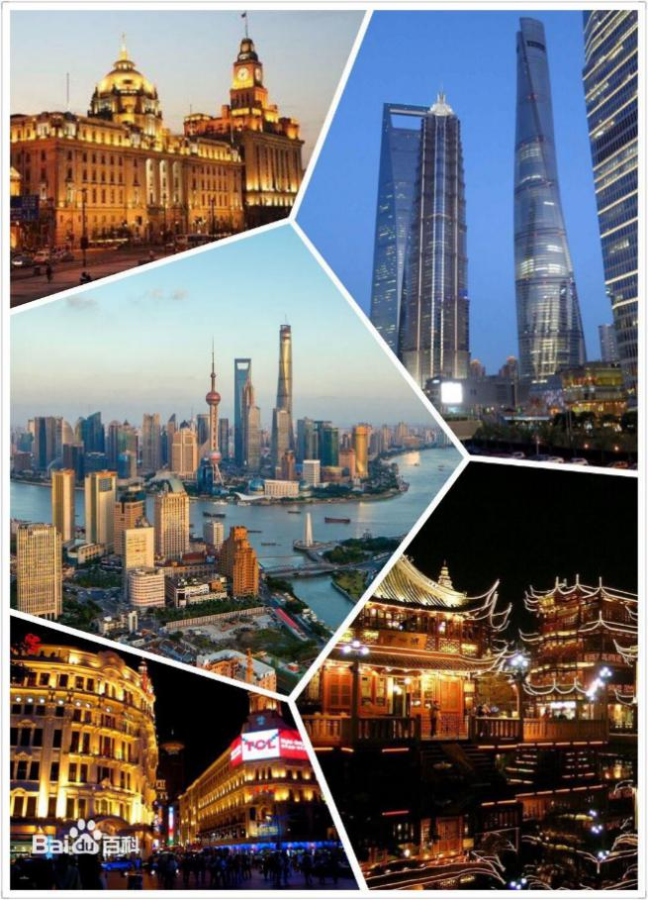
Shanghai, “Hu” for short and also known as “Shen’, covers an area of 6,340.5 square kilometers and is located halfway down China’s north-south curved coastline. It is a place with convenient traffic conditions and vast hinterland as well as a great harbor for rivers and seas. It has 16 administrative districts. Shanghai features a subtropical monsoon climate where the weather is mild and humid with four distinct seasons and there is a lot of sunshine and rain. It has shorter spring and autumn and longer winter and summer. Due to significant in-migration and rapid growth of non-native immigrants, its gross population has kept expanding. At the end of 2017, its permanent population has reached up to 24.197 million, and the average life expectancy of the registered population was 83.37 years, which was equivalent to that in developed countries. Shanghai's per capita GDP, calculated by permanent population and current-year exchange rate, reached RMB 3.013386 trillion in 2017, which is an increase of 6.9% from 2016. This is equivalent to the GDP of moderately developed countries or regions.
Shanghai strives to build the basic framework of an innovation center of science and technology with global influence and basically develop a socialist, modern and international metropolis by 2020. By 2035, it will be basically built into an outperforming global city, a desirable city of innovation, humanity and ecology, as well as a socialist, modern and international metropolis with global influence.
I. Urban Tourism
Shanghai is a city with rich culture and one of China’s major tourist cities. It has 247 star-rated hotels, of which 68 are five-star hotels; 1,276 travel agencies, of which 134 handle outbound tourism business; 98 A-class tourist attractions; 49 tourism advisory service centers; and 4 tourist distribution centers. Since the 1990s, Shanghai has built a number of functional buildings that are well known both nationally and internationally. These buildings have become a fascinating urban landscape as well as new tourist landmarks in Shanghai, which provides it with a modern appearance
[The Bund] The Bund extends four kilometers from the Garden Bridge to the Nanpu Bridge. It is a famous tourist attraction as well as a business landmark of Shanghai. On the west side of the Bund are Chinese and Western architectural complexes with different styles, which are also known as the exotic building clusters in the Bund of Shanghai and stand as the epitome of the history of Shanghai. In the Bund, tourists can enjoy a panoramic view of the amazing scenes on both sides of the Huangpu River. (Metro Line 2 & 10, East Nanjing Road Station)
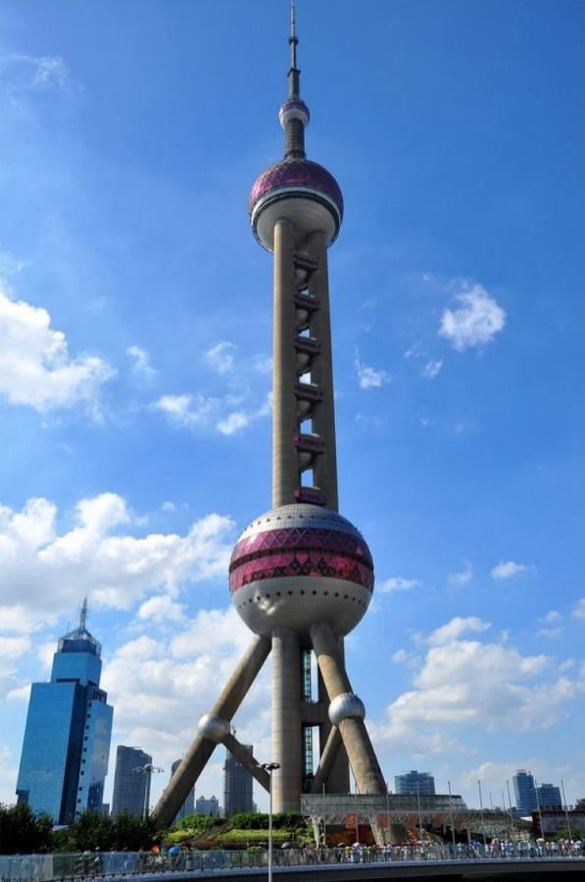
[Oriental Pearl TV Tower] The Oriental Pearl TV Tower is one of the landmark buildings in Shanghai that features broadcasting, entertainment, and tourist facilities. It is 468 meters above the ground, the highest TV tower in Asia and the third highest in the world. Tourists can get a bird’s-eye view of the city at the 263-meter-high observatory deck of the Upper Sphere and the 350-meter-high “Space Cabin.” The Revolving Restaurant is 267 meters high, which is the highest one of its kind in Asia. On the ground floor there is the Shanghai Museum of Urban Historical Development, which features Shanghai’s history since its opening as a commercial port. (Metro Line 2, Lujiazui Station)
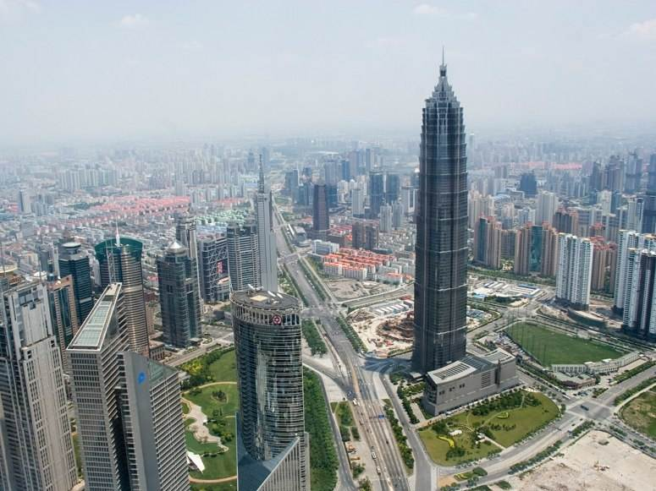
[Jin Mao Tower] The Jin Mao Tower in the Lujiazui Finance and Trade Zone in Pudong is one of the city’s landmark buildings. It has total floor area of 290,000 square meters and is 420.5 meters high. It has 88 stories above the ground and 3 stories under the ground. It offers business and tourism services, hotels, recreation and shopping. The 88th floor is a sightseeing hall which offers a breathtaking bird’s-eye view of the city to up to more than 1,000 tourists at a time. (Metro Line 2, Lujiazui Station)
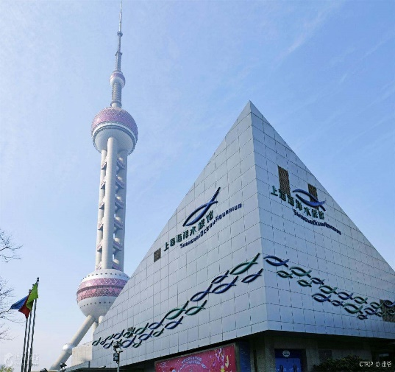
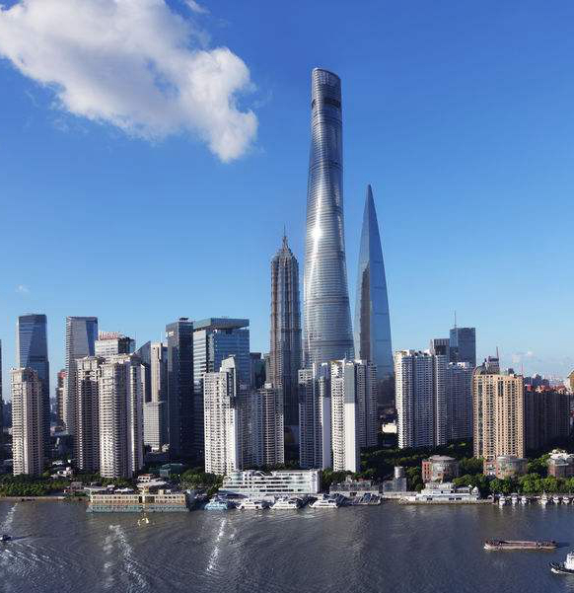
[Shanghai Tower] The Shanghai Tower is located in the heart the Lujiazui Finance and Trade Zone in Pudong, which is the highest skyscraper in China and the second highest skyscraper in the world. It is also the highest and largest commercial building in Shanghai. The main building is 632 meters, with 127 stories above the ground and 5 stories under the ground. It has a total floor area of 578,000 square meters. It is a green vertical city that offers services for offices, hotels, exhibitions, business and sightseeing. It is uniquely built with rounded triangle facade of layered structure which spirals up in 120 degrees, forming a unique and elegant streamlined glass crystal which reflects the vitality of modern China. As a new landmark in Shanghai, it outlines a beautiful urban skyline alongside with the Oriental Pearl Tower and other landmark buildings in Lujiazui. (Metro Line 2, Lujiazui Station)
[Shanghai Ocean Aquarium] Shanghai Ocean Aquarium is located in the Lujiazui Finance and Trade Zone in Pudong. It has a total floor area of 22,400 square meters where 14,000 marine aquatic organisms of more than 300 species from all continents in the world live. The 120-meter-long submarine sightseeing tunnel is one of the longest submarine sightseeing tunnels in the world, which allows tourists to appreciate the mysterious undersea world from all angles. (Metro Line 2, Lujiazui Station)
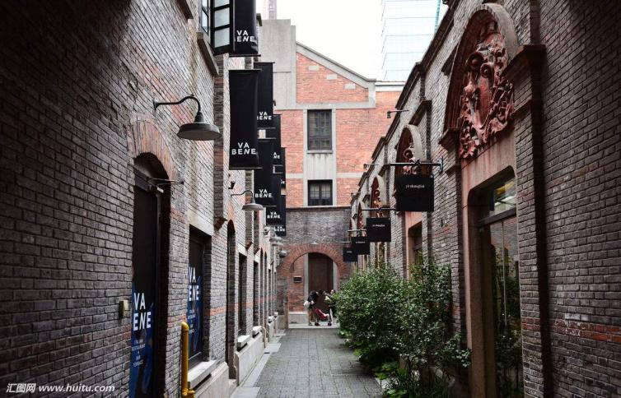
[Shanghai Xintiandi] Shanghai Xintiandi is an urban tourist attraction that shows Shanghai’s historical cultural scenes. It is located in central Shanghai with a total area of 30,000 square meters. It is based on unique Shikumen architecture style and combines traditional Shikumen lanes with modern buildings. It integrates history, culture, tourism, food services, business, and entertainment. (Metro Line 1, South Huangpi Road Station; Metro Line 10 & 13, Xintiandi Station)
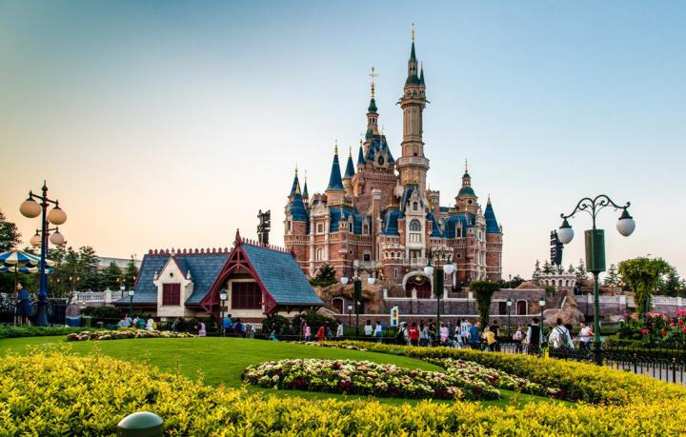
[Shanghai Disney Resort] Shanghai Disney Resort, which opened on June 16, 2016, is located in the heart of the Pudong New Area in Shanghai. It is Chinese Mainland’s first, Asia’s third and the world’s sixth Disney resort. It consists of one theme park - Shanghai Disneyland, which comprises of six theme parks including the Mickey Avenue, Gardens of Imagination, Adventure Isle and Tomorrow land; two theme hotels, i.e., Shanghai Disneyland Hotel and Toy Story Hotel; one international shopping, dining and entertainment area, including the Disneytown, where there is the Walt Disney Grand Theatre in which the first Mandarin version of the popular Broadway musical “The Lion King” is performed; and the recreational Wishing Star Park that is composed of quiet gardens and sparkling lakes. (Metro Line 11, Disney station)
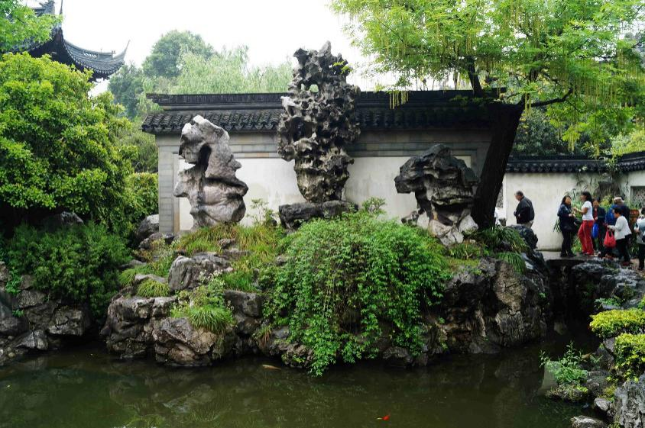
[Yuyuan Garden] The Yuyuan Garden in central Shanghai was built in the 38th year during the Reign of Jiajing Emperor of Ming Dynasty (1559 AD). With a history of over 400 years, it is a famous classical garden in the south of the Yangtze River. It has 48 scenic spots and blends the garden architecture styles of Ming and Qing dynasties together, known as the “City Forest”. Overtime, it has collected thousands of valuable cultural relics such as calligraphy, painting, furniture, and ceramics. (Metro Line 10, Yuyuan Garden Station)
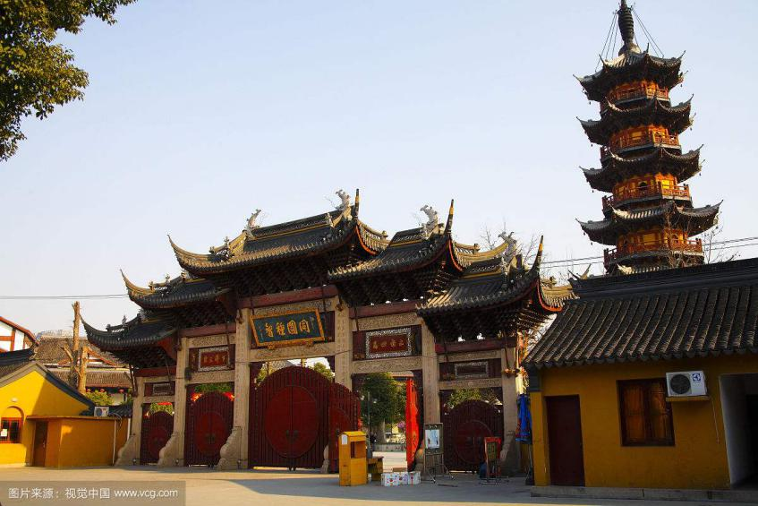
[Longhua Temple] The Longhua Temple in Xuhui District was built in 247 AD in the Three Kingdoms Period with a history of more than 1,700 years. It is the oldest, largest, and most magnificent Buddhist temple in Shanghai that houses precious cultural relics such as scriptures, golden seals, and Buddhist statues of Tang Dynasty, Five Dynasties, and Ming and Qing Dynasties. The Longhua Temple is a religious tourist attraction that consists of ancient temples, ancient towers, Longhua temple fairs and the Longhua Evening Bell. (Metro Line 11 & 12, Longhua Station)
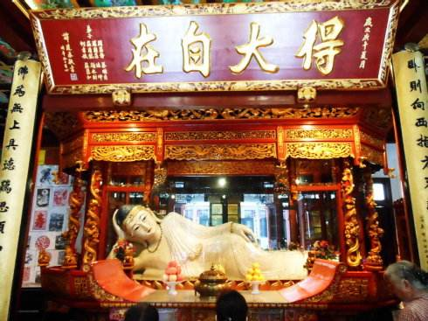
[Jade Buddha Temple] The Jade Buddha Temple is a famous ancient Buddhist temple in Jing’an District, which was built in 1882 and named after two jade Buddhist statues that Hui Gen, a monk from Putuo Mountain, brought back from Myanmar. The temple comprises of magnificent buildings such as the Tianwang Hall, the Main Shrine Hall, the Jade Buddha Hall and the Sutra Hall, among which the Jade Buddha Hall has a 1.9-meter-high, 3.4-meter-wide jade statue of Sakyamuni. (Metro Line 13, Jiangning Road Station)
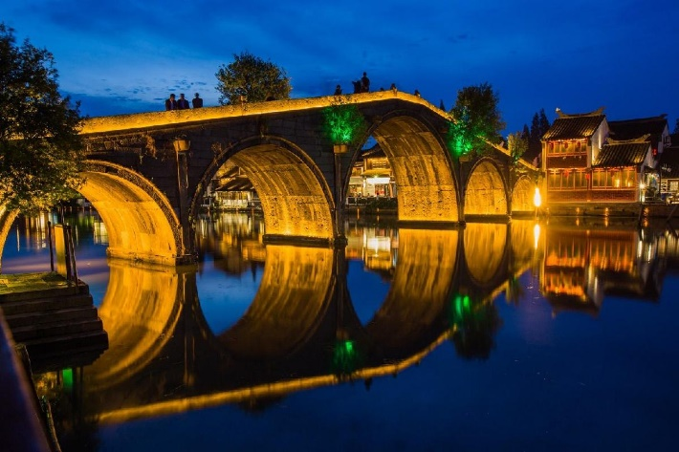
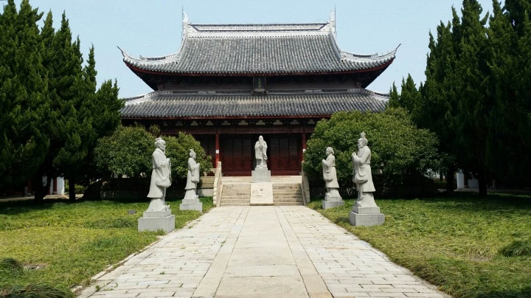
[Confucius Temple] The Confucius Temple in Jiading District was built in the twelfth year in the Jiading Period of Southern Song Dynasty (1219 AD). It is always known as the most famous temple in the Wu Region in the ancient times. The temple has exhibition halls with articles related to the traditional Chinese examination system and three high stone tablets, namely, “Yucai (Cultivation of Talent)’, “Xingxian (Advocate of Virtuous Deeds)” and “Yangao (Diligent Study)”, which represents people’s respect to education and Confucius’s teachings. In addition, the Confucius Temple also has stone tablets carved with the calligraphy by Zhu Xi, a famous philosopher and educator in the Song Dynasty. (Metro Line 11, North Jiading Station, take the Jiading No. 13 Bus after exiting the station)
[Zhujiajiao] Zhujiajiao, also known as “the Venice of the East”, is the best-preserved ancient town of southern Yangtze River in Shanghai. Villages and fairs were formed 1700 years ago in the Three Kingdoms Period, which were developed into prosperous towns during the Reign of Wanli Emperor of Ming Dynasty. The town has stone bridges, black-awning boats, small bridges over flowing streams, and Ming and Qing houses, which together constitute a leisurely and simple pastoral picture of southern Yangtze River style. (Metro Line 17, Zhujiajiao Station)
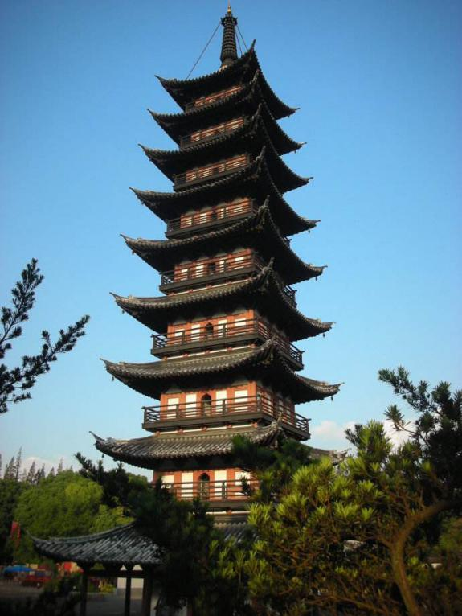
[Square Tower] The Square Tower in Songjiang District was built in the second year during the Qianyou Period of Later Han Dynasty (949 AD). It is a nine-storey square tower with a height of 42.5 meters. The tower follows the brick tower structure of Tang Dynasty, with a Humen (a decorative pattern on Xumizuo or furniture) on the four sides on each storey. Most of the bucket arches are from the Song Dynasty. The Square Tower, among the ancient towers in the southern Yangtze River, has retained more of its original architecture. It is surrounded by classical gardens where there are historic relics such as the Wangxian Bridge of Song Dynasty and Lanrui Hall of Ming Dynasty. (Metro Line 9, Zuibaichi Station, take the Songjiang No. 26 Bus after exiting the station)
II. Eating and Shopping
Shanghai has been known as the “Food Paradise”, which brings together the food cultures of various countries in the world and has over 30,000 Chinese, western, leisure, fast-food chains. Western cuisine includes food from over 30 countries and regions such as Italy, France, Japan, Portugal and India, while Chinese cuisine includes food from nearly 20 places in China such as Suzhou, Wuxi, and Nanjing cities and Anhui Province. It also has many food culture areas, such as the City God Temple, Yunnan Road, Huanghe Road, Zhapu Road and Xianxia Road.
Shanghai is also a well-known “Shopping Paradise.” China’s Premier Business Street Nanjing Road and Huaihai Road are both famous places for businesses in China. Commercial facilities such as the Super Brand Mall, Grand Gateway, Plaza 66 and Maison Mode are also home to fashionable goods and top brands.
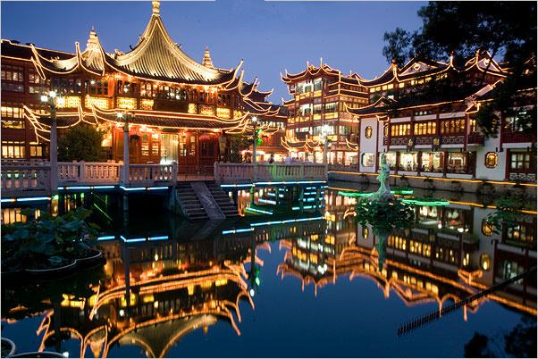
[ City God Temple] The City God Temple brings together antique goods, restaurants and teahouses with rich Shanghai sense culture through Huabaolou Antiques Market and Cangbaolou Antiques and Artworks Market. It also has famous Shanghai snacks such as the Nanxiang Steamed Meat Dumplings, Sansi Eyebrow-shaped Crisp, Osmanthus Paste Cake, Pigeon Egg Balls, and Eight-Treasure Rice Pudding. It attracts domestic and foreign visitors with its abundant commodities, unique operations and hospitable services. (Metro Line 10, Yuyuan Garden Station)
[Yunnan Road Gourmet Street] Yunnan Road Gourmet Street is located at the crossing of Yan’an Road and Xizang Road, where there are restaurants of various cuisines such as Shanghai local cuisine, Sichuan cuisine, Shandong cuisine, and Huaiyang cuisine. The most popular foods include Beijing Roast Duck, boiled salted duck, ribs rice cakes, sliced cold chicken and hot pots, which have attracted numerous diners at home and abroad. (Metro Line 8, Dashijie Station)
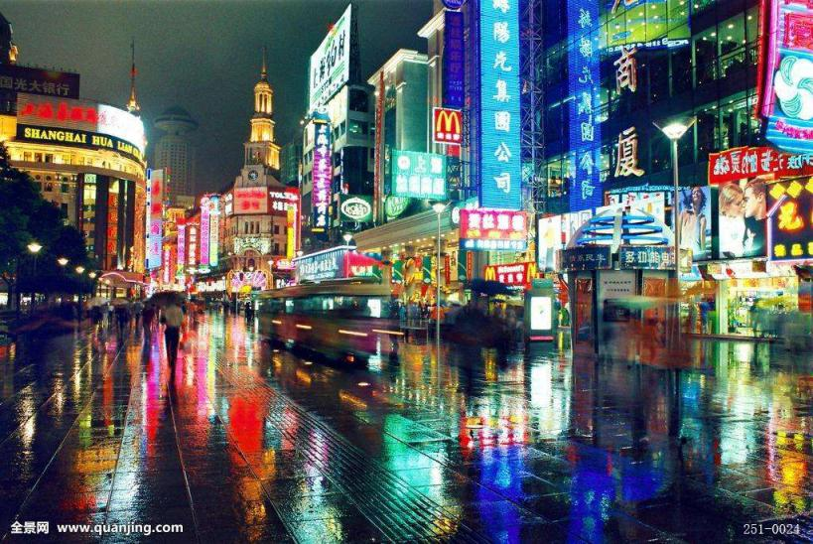
[Nanjing Road Commercial Street] Nanjing Road is known as China’s Premier Business Street. It was popular at the beginning of the 19th century, and has gradually developed into a “metropolis of foreign adventurers” and as the most prosperous business road in Shanghai. In recent years, many long-established stores and hotels have renovated, and new shopping centers have been built, including large shopping malls such as Shanghai No.1 Department Store, New World, Orient Shopping Centre, Wing On Department Store, and Landmark Plaza. These department stores are the shopping paradise for Chinese and foreign tourists. (Metro Line 1, 2 & 8, People’s Square Station; Metro line 2 & 10, East Nanjing Road Station)
[Huaihai Road Commercial Street] The bustling and elegant Huaihai Road Business Street reflects modern urban and shopping culture in Shanghai. There are stores that are elegantly decorated, as well as shops of various styles where numerous high quality goods are displayed. Large shopping malls on the street include the Shanghai Times Square, Hong Kong Plaza, Central Plaza, Pacific Department Store, Paris Spring Mall, and Parkson Shopping Center. (Metro Line 1, South Huangpi Road Station; Metro Line 1 & 12, South Shaanxi Station)
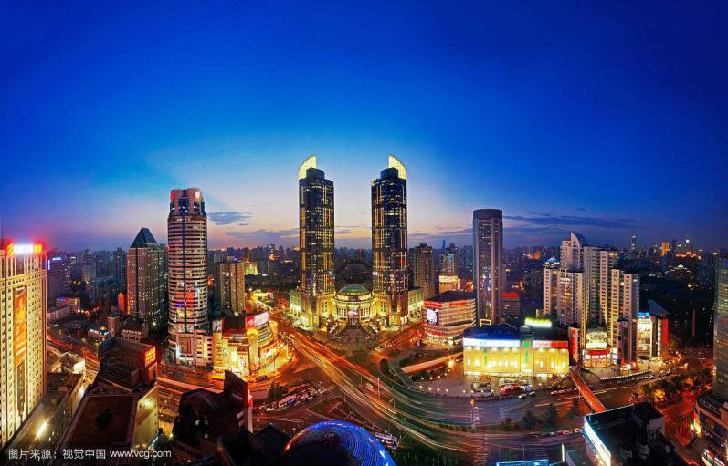
[Xujiahui] Xujiahui is the most important commercial center and public activity center in southwest Shanghai. The central square is 1.2 square kilometers and integrates shopping and leisure. A number of well-known shopping malls are built here, including the Grand Gateway, Orient Shopping Centre, Pacific Department Store, Huijin Department Store, MetroCity, and Huilian Shopping Center. (Metro Line 1, 9 & 11, Xujiahui Station)
III. Rail Transit
[Rail Transit Lines] Shanghai currently has 17 rail transit lines that are running and under operation. See the traffic map for details. You can also download the “Metro大都会” App through mobile phones for detailed inquiries about travel routes.
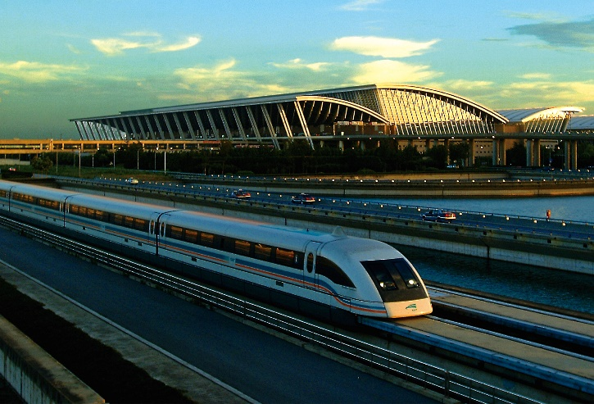
[Maglev Demonstration Line] The Shanghai Maglev Demonstration Line, which began operations in December 2002, is the first high-speed maglev railway in the world that was officially put into commercial operation as well as the first high-speed transportation line in China that features urban transportation, sightseeing, and tourism. The demonstration line is about 30 kilometers long and takes 7 minutes for one travel.

