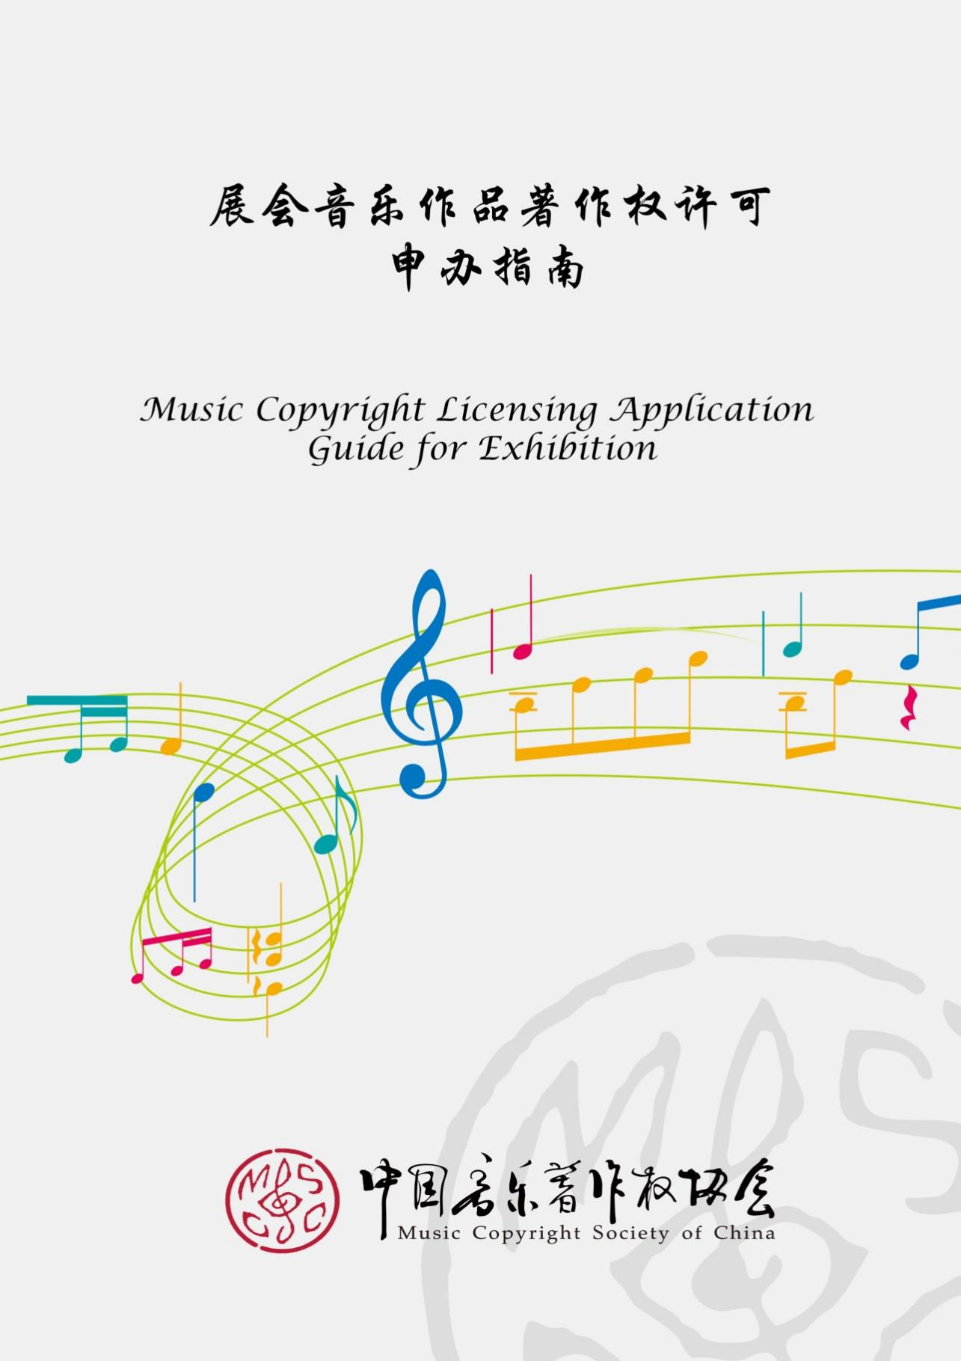
- 法律规定Legal Provisions
根据《中华人民共和国著作权法》及其实施条例的规定，音乐作品是指歌曲、交响乐等能够演唱或者演奏的带词或者不带词的作品；音乐作品受著作权法保护。除法律明确规定的情形外，音乐作品的使用人应当依法事先获得著作权人的许可，并向著作权人支付报酬。
According to China's Copyright Law and its implementing regulations, a musical work is a work with or without lyrics that can be sung or performed, such as a song or symphony; musical works are protected by the Copyright Law. Except for circumstances clearly stipulated by law, the user of a musical work shall obtain prior permission from the copyright owner in accordance with the law and pay remuneration to the copyright owner.

- 适用范围Scope of Application
- 展台、场馆等背景音乐。
Background music for exhibition exhibits, venues, etc.
- 展台、舞台等现场表演。
Live performances at exhibits, stages, etc.
- 新产品、新技术发布会等现场活动。
On-site activities such as new product and technology launches.

- 服务机构Service Provider
中国音乐著作权协会（简称“音著协”）是经国家版权局批准成立的中国(除港澳台地区外)唯一的音乐作品著作权集体管理组织，也是国际作者和作曲者协会联合会（CISAC）的成员。音著协的著作权管理范围覆盖世界范围内300多万词曲作者的超过1800万首音乐作品。
Music Copyright Society of China (“MCSC”) is the only collective management organization for copyrights of musical works in China (except Hong Kong, Macao and Taiwan regions) approved by the National Copyright Administration, and a member of the International Confederation of Societies of Authors and Composers (CISAC). MCSC manages more than 18 million musical works of more than 3 million songwriters worldwide.
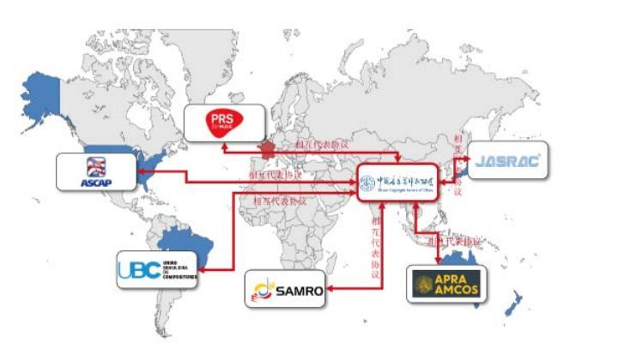

- 申办著作权许可Apply for Copyright License
展会期间如需使用音乐作品，应于展会前，向音著协申办使用音乐作品的著作权许可，并缴纳著作权使用费。
If you need to use musical works during the exhibition, you should apply for musical works’ copyright license from MCSC before the exhibition and pay copyright royalties.

使用费标准参照短期展览（车展、时装展等）（修订版）标准：
此类场所按照展台费的1%计算或
（1）仅以机械表演方式使用音乐作品的：每展台每天200元；
（2）以机械表演和现场表演两种方式使用音乐作品的：每展台每天500元。
（3）设有荧光屏播放音乐作品的，则：
荧光屏之对角线长度不超过20英寸的，每个荧光屏每个展期加收200元；
荧光屏之对角线长度在20-50英寸的，每个荧光屏每个展期加收500元；
荧光屏之对角线长度超过50英寸的，每个荧光屏每个展期加收1000元；
电视墙类超大型屏幕，每个屏幕每个展期加收3000元。
（本标准中所指展台以100平方米为单位，不足100平方米的按100平方米计算）。
The rate of the license fee is based on the standard for short-term exhibitions (auto shows, fashion shows, etc.) (revised version):

Such venues shall be charged 1% of the exhibit fee or
- For the use of musical works only in mechanical performance: RMB 200 per day per exhibit;
- Use of musical works by means of both mechanical performance and live performance: RMB 500 per day per exhibit.
- Equipped with a fluorescent screen to play music:
If the diagonal length of the fluorescent screen does not exceed 20 inches, an additional RMB 200 will be charged for per fluorescent screen per exhibition period;
If the diagonal length of the fluorescent screen is 20-50 inches, an additional RMB 500 will be charged for per fluorescent screen per exhibition period;
If the diagonal length of the fluorescent screen exceeds 50 inches, an additional RMB 1,000 will be charged for per fluorescent screen per exhibition period;
For TV wall and other large screens, an additional RMB 3,000 will be charged for per screen per exhibition period.
(The exhibits referred to in this standard are counted in units of 100 square meters, and those less than 100 square meters are counted as 100 square meters).
需更多详细信息可与中国音乐著作权协会联系：
联系人贾晓晨 01065232656转521 18618454946 jiaxiaochen@mcsc.com.cn
For more detailed information, please contact Music Copyright Society of China:
Contact: Jia Xiaochen 01065232656 ext. 521 18618454946
jiaxiaochen@mcsc.com.cn
